Computer Science
COURSE CONTENT:
Unit 1 – Principles of Computer Science | Unit 2 – Application of computational thinking
● Topic 1: Computational thinking  ● Topic 2: Data  ● Topic 3: Computers  ● Topic 4: Networks  ● Topic 5: Issues and impact | This paper will assess Topic 6: Problem solving with programming

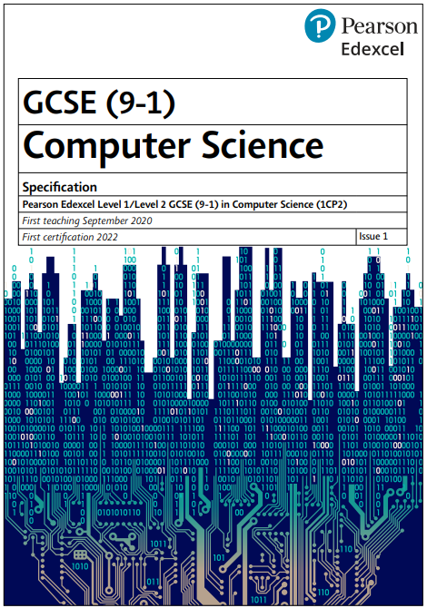

Exam Board
Specification

Edexcel
GCSE Computer Science (9-1)

Assessment Details
In class formative assessments take place at the end of each topic, with summative assessments at the end of each term. Pupils are expected to practice their programming skills on a fortnightly basis by completing programming activities for homework to develop their algorithmic thinking skills.
Computer Science has a broad range of vocabulary that pupils must learn to spell, define and apply accurately in their verbal and written responses.
Final Examinations
2 exams to be taken in May/June 2027
Each exam is out of 75 marks and accounts for 50% of the grade
Unit 1 assesses the pupils principle knowledge of Computer Science.
Unit 2 assesses the pupils programming skill. Pupils complete a set of practical programming assignments in exam conditions.
The final grade is awarded based on the result of both marks combined
Skills/Aptitudes Required for Success
Problem solving/Resilience
Team work
Independent thinking
Good communication
Pupils who enjoy maths and science will succeed in this subject
Staff Contact for Further Information
Mrs McGloin – Assistant Headteacher – Teaching and Learning

